Project Design Phase
Solution Architecture
Date | 04-10-26
Team ID | 23KD1A4230
Project Name | Metro Ticket Generating System in ServiceNow
Maximum Marks | 4 Marks

Solution Architecture
The solution architecture bridges the gap between our business problem (slow, manual ticketing) and our technology solution. It clearly defines how the ServiceNow application is structured, how it behaves, and the steps required to build it.
- 1. System Structure: The platform is divided into four main parts: the User Interface (mobile Service Portal), the Logic Engine (scripts for instant fare calculation), Data Storage (secure backend tables), and Integration (generating QR codes and sending emails).
- 2. Development Phases: The project is delivered in sequential steps: setting up the portal and databases first, writing the dynamic fare logic next, automating the ticket workflows, and finally implementing security and admin dashboards.
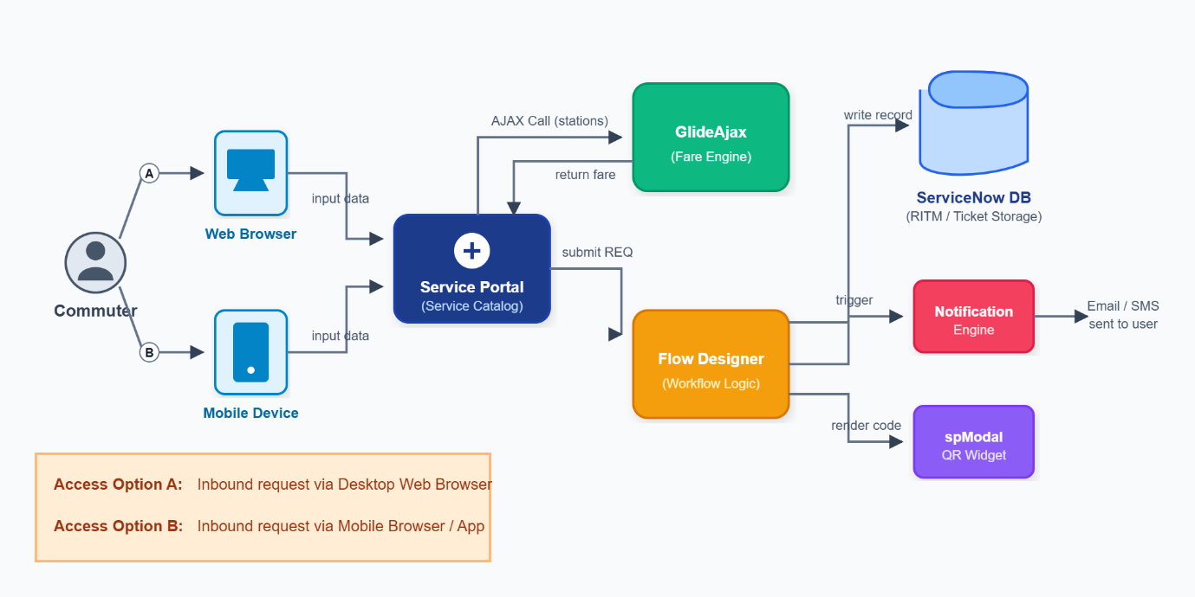
- 3. Core Requirements: The architecture is specifically designed to be highly secure (protecting user data), constantly available, and scalable (handling massive rush hour traffic spikes without lagging).

